REQUEST TO ADD PROGRAM-LEVEL OUTCOMES TO
END-OF-COURSE EVALUATIONS
PURPOSE: The following form is used to request that the Office of Institutional Research add Program Outcomes, General Education Outcomes, or Specialized Accreditor Outcomes to the End-of-Course (EOC) evaluations for obtaining indirect, program-level assessment data to support the university’s annual program assessment efforts.
WHEN & HOW TO SUBMIT:
- The completed form should be submitted NO LATER THAN OCTOBER 1st of the academic year/assessment cycle in which data is to be collected. This is a hard deadline – no question additions will be made after October 1.
- Email the completed form as an attachment to both Kim Brantley in the Office of Institutional Research (branteeb@erau.edu) and Lisa Kopp in the Office of Academic Assessment (koppl1@erau.edu).
PROCESS:
- For each program-level outcome (Program Outcome, General Education Outcome, or Specialized Accreditor Outcome) you wish to assess in the upcoming academic year/assessment cycle, identify the courses in which to assess the outcome via the EOC evaluation. The outcomes must be part of the program assessment plan on file in Taskstream. Due to the length of the core survey, a maximum of three questions can be added to a specific course.
- Transform/rewrite each outcome in the form of a statement or question to be added to the EOC evaluation in the selected courses.
○ Institutional Research and Academic Assessment staff are available to help with statement/question “wordsmithing”,
and will review the wording, obtaining requestor approval on any changes that they may recommend.
- Data collection timeframe is from the September term (WW)/fall term (DB/PC) through the May term (WW)/spring term (DB/PC).
- Reports will be aggregated by outcome across course sections, reported by term and will not identify instructor(s).
- Results will be uploaded to the requesting program’s Data Repository area in Taskstream by mid-August of the following calendar year, six weeks in advance of the end-of-September deadline for annual assessment deliverables.

BEST PRACTICE ASSESSEMENT STRATEGY
▪ Map Program Outcomes (PO's) from your assessment plan to courses
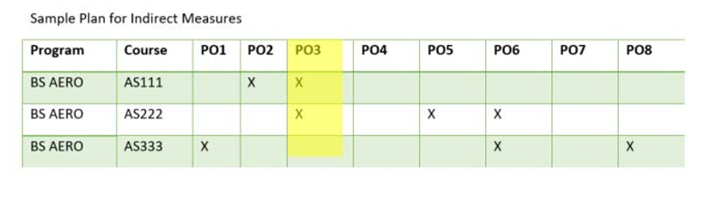
PO1: “Student will be able to identify and apply appropriate statistical analysis, to include techniques in data collection, review, critique, interpretation, and inference in the aviation and aerospace industry.”

PO2:” Students will have an ability to function on multidisciplinary teams.”

PO3: "Knowledge of basic concepts in aviation safety as they pertain to the aviation, aerospace, and aeronautics industry”.

SAMPLE FORM

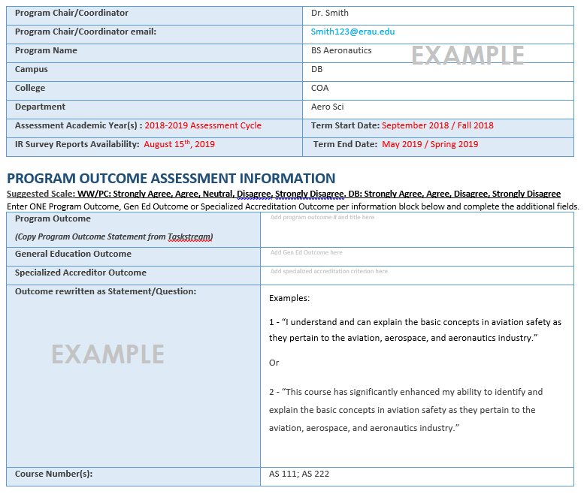

REQUEST TO ADD PROGRAM-LEVEL OUTCOMES TO END-OF-COURSE EVALUATIONS
Program Chair/Coordinator
Program Chair/Coordinator email:
Program Name
Campus
College
Department
Assessment Academic Year: 2022-2023 Assessment Cycle | Term Start Date: September 2022 / Fall 2022
IR Survey Reports Availability: August 15th, 2023 | Term End Date: May 2023 / Spring 2023

Program Outcome Assessment Information
Suggested Scale: WW/PC: Strongly Agree, Agree, Neutral, Disagree, Strongly Disagree. DB: Strongly Agree, Agree, Disagree, Strongly Disagree
Enter ONE Program Outcome, Gen Ed Outcome or Specialized Accreditation Outcome per information block below and complete the additional fields.
Program Outcome  (Copy Program Outcome Statement from Taskstream) | Add program outcome # and title here
General Education Outcome | Add Gen Ed Outcome here
Specialized Accreditor Outcome | Add specialized accreditation criterion here
Outcome rewritten as Statement/Question:
Course Number(s) :
Program Outcome  (Copy Program Outcome Statement from Taskstream) | Add program outcome # and title here
General Education Outcome | Add Gen Ed Outcome here
Specialized Accreditor Outcome | Add specialized accreditation criterion here
Outcome rewritten as Statement/Question:
Course Number(s):
Program Outcome  (Copy Program Outcome Statement from Taskstream) | Add program outcome # and title here
General Education Outcome | Add Gen Ed Outcome here
Specialized Accreditor Outcome | Add specialized accreditation criterion here
Outcome rewritten as Statement/Question:
Course Number(s):
Program Outcome  (Copy Program Outcome Statement from Taskstream) | Add program outcome # and title here
General Education Outcome | Add Gen Ed Outcome here
Specialized Accreditor Outcome | Add specialized accreditation criterion here
Outcome rewritten as Statement/Question:
Course Number(s):
Program Outcome  (Copy Program Outcome Statement from Taskstream) | Add program outcome # and title here
General Education Outcome | Add Gen Ed Outcome here
Specialized Accreditor Outcome | Add specialized accreditation criterion here
Outcome rewritten as Statement/Question:
Course Number(s):
Program Outcome  (Copy Program Outcome Statement from Taskstream) | Add program outcome # and title here
General Education Outcome | Add Gen Ed Outcome here
Specialized Accreditor Outcome | Add specialized accreditation criterion here
Outcome rewritten as Statement/Question:
Course Number(s):

Additional Notes:
For IR & OAA Office Use Only:
Project Survey Name: |  | Term Start:
Term Start: |  | Survey OAA:
EK Hierarchy: |  | Reports Created:
EK Logic: |  | Reports OAA:
EK Mapping:
Update Syntax:
Survey OAA:
Notes:

